班級： 座號： 姓名：

1. 試著回答下列問題
2. 我們知道

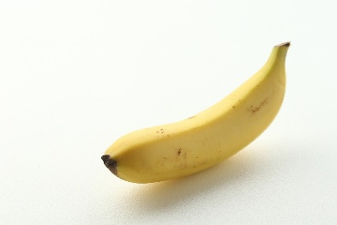

2×

+

=

1×

1×

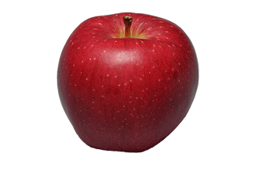



2×

+

=

1×

1×

那…



？

+

=

1×

1×

1. 我們知道

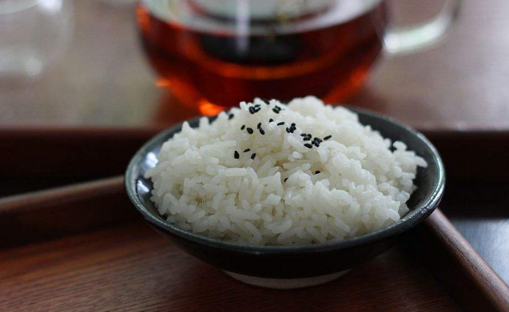

2×

+

=

1×

1×

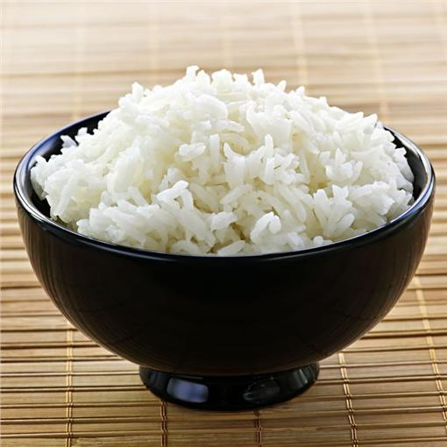

2×

+

=

1×

1×

那…



？

+

=

1×

1×

1. 小結論：
2. 想把分開寫的兩項東西合併起來一起寫(講)的條件是…

這兩項東西必須是__________________

1. 下面是琉球鄉的天氣溫度圖。
2. 什麼時候氣溫最高？圈起來！
3. 什麼時候氣溫最低？圈起來！
4. 什麼時候氣溫沒有變化？圈起來！
5. 什麼時候氣溫上升最快？圈起來！
6. 什麼時候氣溫下降最快？圈起來！

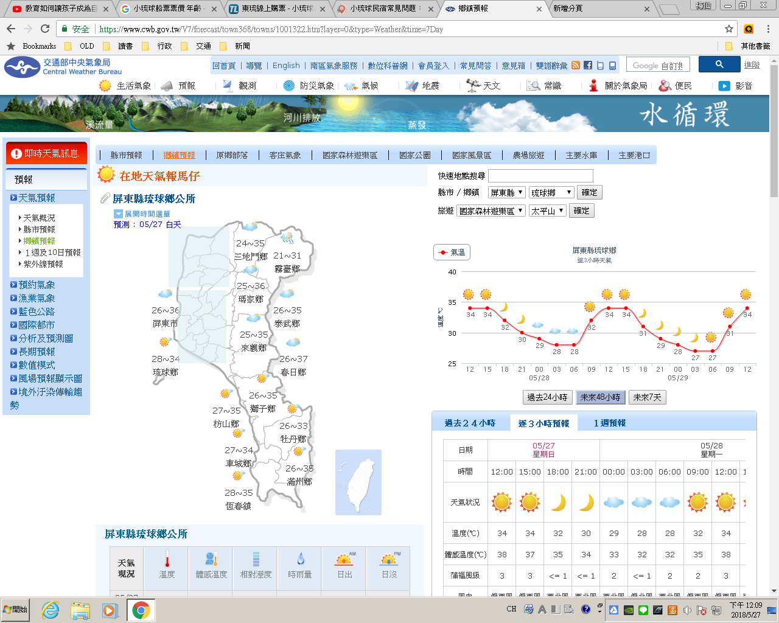

1. 套套看！下面三個圖形(粗黑線條)。
2. 哪一個圖形y的高度在x的值改變時沒有變化？ 🞏A 🞏B 🞏C
3. 哪一個圖形y的高度在x的值改變時變化固定？ 🞏A 🞏B 🞏C
4. 哪一個圖形y的高度在x的值改變時變化不固定？ 🞏A 🞏B 🞏C

|  |  |  |
| --- | --- | --- |
| A | B | C |

1. 承上題，猜猜看！上面三個圖形。
2. 函數y=1是哪一個圖形？ 🞏A 🞏B 🞏C
3. 函數y=x是哪一個圖形？ 🞏A 🞏B 🞏C
4. 函數y=x2是哪一個圖形？ 🞏A 🞏B 🞏C
5. 承第4題，試著回答下列問題

|  |  |  |
| --- | --- | --- |
| 1. 圖A+圖B=？ | 1. 圖A+圖C=？ | 1. 圖B+圖C=？ |
| B  A | C  A | C  B |

1. 試著回答下列問題

|  |  |  |
| --- | --- | --- |
| 1. 1+1=？ | 1. x+x=？ | 1. x2+x2=？ |
| 1. 1+x=？ | 1. 1+x2=？ | 1. x+x2=？ |

1. 利用下面y=x和y=x-2的圖形畫出y= x(x-2)的圖形。

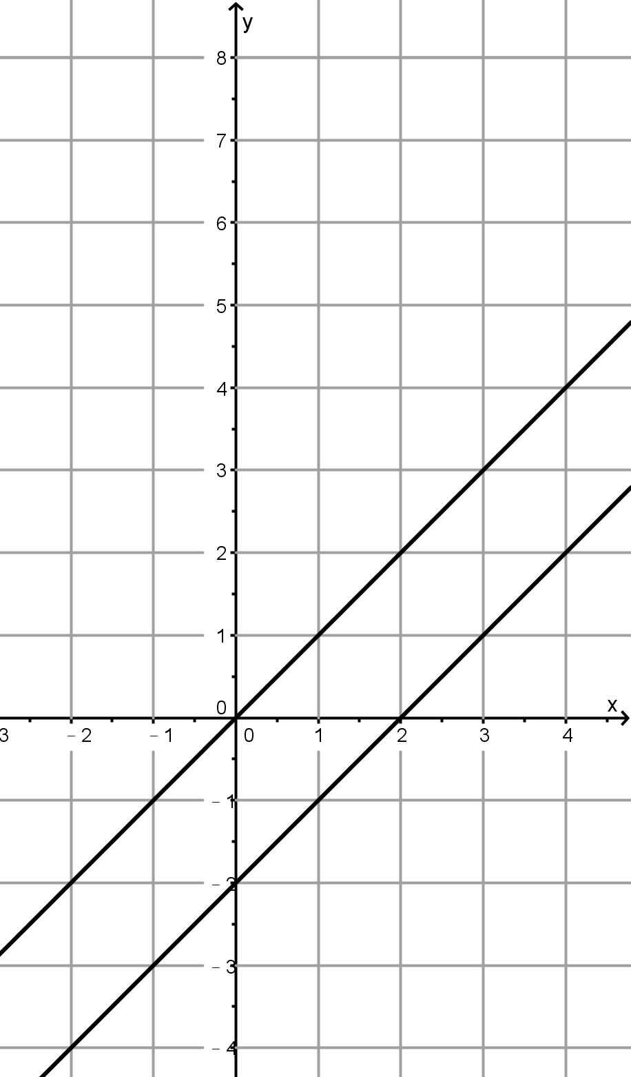

y=x-2

y=x

1. 分開算和一起算
2. 甲班有27個學生，班上要舉辦慶生活動，為每個學生買了一塊蛋糕和一杯飲料，一塊蛋糕的價錢是 元，一杯飲料是

，請將全班的花費列式。

1. 甲乙兩班聯合舉辦慶生活動，為每個學生買了一塊蛋糕和一杯飲料，一塊蛋糕的價錢是 元，一杯飲料是 元，請列出兩班的總花費。
2. 請將下面的算式乘開並化簡。

|  |  |  |  |  |  |  |  |  |  |  |  |  |  |  |  |  |  |  |  |  |  |  |  |  |  |  |  |  |  |  |  |
| --- | --- | --- | --- | --- | --- | --- | --- | --- | --- | --- | --- | --- | --- | --- | --- | --- | --- | --- | --- | --- | --- | --- | --- | --- | --- | --- | --- | --- | --- | --- | --- |
| 1. (2x+5)×(3x+4)=  |  |  |  | | --- | --- | --- | |  | 2x | +5 | | ×) | 3x | +4 | |  | 🞏 | 🞏 | | 🞏 | 🞏 |  | | 🞏 | 🞏 | 🞏 | | 1. (2x+5)×(3x-4)=  |  |  |  | | --- | --- | --- | |  | 2x | +5 | | ×) | 3x | -4 | |  | 🞏 | 🞏 | | 🞏 | 🞏 |  | | 🞏 | 🞏 | 🞏 | |
| 1. (2x-5)×(3x+4)=  |  |  |  | | --- | --- | --- | |  | 2x | -5 | | ×) | 3x | +4 | |  | 🞏 | 🞏 | | 🞏 | 🞏 |  | | 🞏 | 🞏 | 🞏 | | 1. (2x-5)×(3x-4)=  |  |  |  | | --- | --- | --- | |  | 2x | -5 | | ×) | 3x | -4 | |  | 🞏 | 🞏 | | 🞏 | 🞏 |  | | 🞏 | 🞏 | 🞏 | |

1. 請根據下面的算式完成填空。

|  |  |  |  |  |  |  |  |  |  |  |  |  |  |  |  |  |  |  |  |  |  |  |  |  |  |  |  |  |  |  |  |
| --- | --- | --- | --- | --- | --- | --- | --- | --- | --- | --- | --- | --- | --- | --- | --- | --- | --- | --- | --- | --- | --- | --- | --- | --- | --- | --- | --- | --- | --- | --- | --- |
| |  |  |  | | --- | --- | --- | |  | 3x | +4 | | ×) | 🞏 | -1 | |  | -3x | -4 | | 15x2 | +20x |  | | 15x2 | +17x | -4 | | |  |  |  | | --- | --- | --- | |  | 4x | -1 | | ×) | 🞏 | -5 | |  | 🞏 | 🞏 | | 🞏 | 🞏 |  | | 8x2 | -22x | +5 | |
| |  |  |  | | --- | --- | --- | |  | -3x | +2 | | ×) | 🞏 | 🞏 | |  | 🞏 | 🞏 | | 🞏 | 🞏 |  | | -24x2 | +31x | -10 | | |  |  |  | | --- | --- | --- | |  | 🞏 | 🞏 | | ×) | 🞏 | 🞏 | |  | 🞏 | 🞏 | | 🞏 | 🞏 |  | | 3x2 | +16x | +5 | |

1. 請根據下面的算式完成填空，仔細想想除法和乘法的關係。

|  |  |  |  |  |  |  |  |  |  |  |  |  |  |  |  |  |  |  |  |  |  |  |  |  |  |  |  |  |  |  |  |  |  |  |  |  |  |  |  |  |  |  |  |  |  |  |
| --- | --- | --- | --- | --- | --- | --- | --- | --- | --- | --- | --- | --- | --- | --- | --- | --- | --- | --- | --- | --- | --- | --- | --- | --- | --- | --- | --- | --- | --- | --- | --- | --- | --- | --- | --- | --- | --- | --- | --- | --- | --- | --- | --- | --- | --- | --- |
| 1. (2x+5)×(🞏+🞏)=6x2+23x+20  |  |  |  | | --- | --- | --- | |  | 2x | +5 | | ×) | 🞏 | 🞏 | |  | 🞏 | 🞏 | | 🞏 | 🞏 |  | | 6x2 | +23x | +20 | | 1. (6x2+23x+20)÷(2x+5)=  |  |  |  |  |  | | --- | --- | --- | --- | --- | |  |  | 🞏 | 🞏 |  | | 2x | +5 | 6x2 | +23x | +20 | |  |  | 🞏 | 🞏 |  | |  |  |  | 🞏 | 🞏 | |  |  |  | 🞏 | 🞏 | |  |  |  |  | 🞏 | |

1. 請根據下面的算式完成填空，仔細想想除法和乘法的關係。

|  |  |  |  |  |  |  |  |  |  |  |  |  |  |  |  |  |  |  |  |  |  |  |  |  |  |  |  |  |  |  |  |  |  |  |  |  |  |  |  |  |  |  |  |  |  |  |
| --- | --- | --- | --- | --- | --- | --- | --- | --- | --- | --- | --- | --- | --- | --- | --- | --- | --- | --- | --- | --- | --- | --- | --- | --- | --- | --- | --- | --- | --- | --- | --- | --- | --- | --- | --- | --- | --- | --- | --- | --- | --- | --- | --- | --- | --- | --- |
| 1. (2x+5)×(🞏+🞏)+🞏   =6x2+23x+21   |  |  |  | | --- | --- | --- | |  | 2x | +5 | | ×) | 🞏 | 🞏 | |  | 🞏 | 🞏 | | 🞏 | 🞏 |  | | 6x2 | +23x | 🞏 |   21 | 1. (6x2+23x+21)÷(2x+5)=  |  |  |  |  |  | | --- | --- | --- | --- | --- | |  |  | 🞏 | 🞏 |  | | 2x | +5 | 6x2 | +23x | +21 | |  |  | 🞏 | 🞏 |  | |  |  |  | 🞏 | 🞏 | |  |  |  | 🞏 | 🞏 | |  |  |  |  | 🞏 | |